Mechanical Overview

Year: 2021 Semester: Fall Team: 06 Project: RevEx

Creation Date: 09/20/2021 Last Modified: March 3, 2015

Author: Matthew Rumple Email: rumple0@purdue.edu

Assignment Evaluation:

|  |  |  |  |  |
| --- | --- | --- | --- | --- |
| **Item** | **Score (0-5)** | **Weight** | **Points** | **Notes** |
| **Assignment-Specific Items** | | | | |
| **Commercial Packaging Analysis 1** |  | x2 |  |  |
| **Commercial Packaging Analysis 2** |  | x2 |  |  |
| **CAD Model Illustrations** |  | x4 |  |  |
| **Project Packaging Specifications** |  | x2 |  |  |
| **PCB Footprint Layout** |  | x2 |  |  |
| **Writing-Specific Items** | | | | |
| **Spelling and Grammar** |  | x2 |  |  |
| **Formatting and Citations** |  | x1 |  |  |
| **Figures and Graphs** |  | x2 |  |  |
| **Technical Writing Style** |  | x3 |  |  |
| **Total Score** |  | | |  |

5: Excellent 4: Good 3: Acceptable 2: Poor 1: Very Poor 0: Not attempted

Comments:

*Comments from the grader will be inserted here.*

1. Commercial Product Packaging

The packaging for the embedded electronics will be straightforward, and the motor will be mounted using screws. Most of the brace will be 3D printed, allowing for complex geometries to be created without the need for complicated tooling. The area of the design where the most guidance is needed is the wearable component. It is important that the design is comfortable to wear and will not pinch or rub against the user’s skin. Therefore, the commercial product packaging analysis is mainly focused on wearable external arm products, and how they achieved a comfortable mount and fit. Any electrical components, such as PCB’s and sensors will be covered and mounted on the upper arm section of the product. This design will also house the IMU in a standard location to facilitate arm joint position calculations.

* 1. Product #1 - ALEx

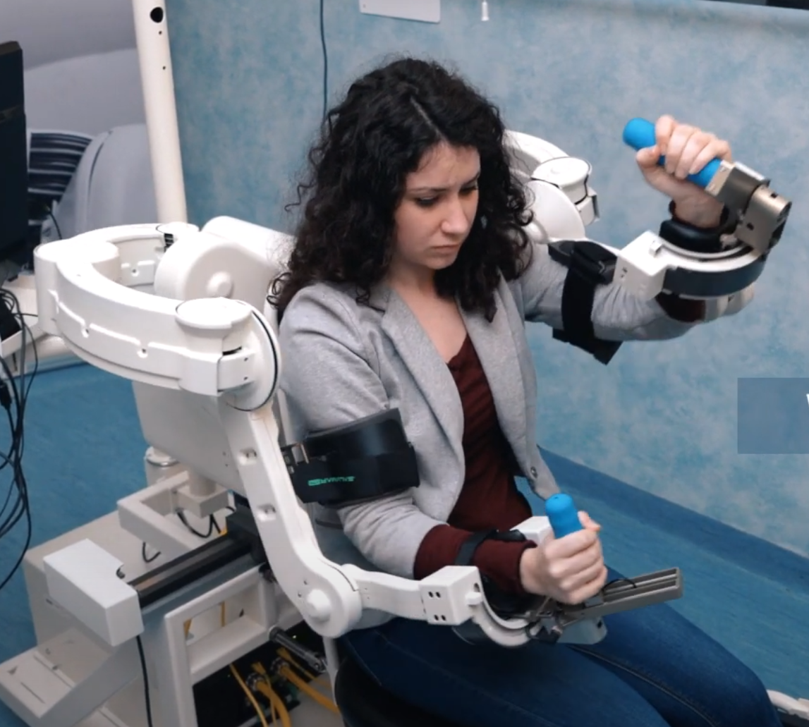

Figure 1. ALEx upper body rehabilitation solution

ALEx [1] is a 6 degree of freedom (DOF) system that is used for rehabilitation of the upper torso and arms. The common candidate to use this product is someone who has recently gone through joint surgery and needs to retrain their muscle memory. This system provides torque and force in many directions, allowing the user to experience an accurate, immersive VR experience while using it.

The focus of this analysis is to determine how the product attaches to the user and maintains comfort. By looking at ALEx, it is securely mounted to the user’s arm using padding and straps. The rigid attachment allows for load to be distributed throughout key parts in the arm. This device is mounted about 5 centimeters away from the arm, and is directly connected to the chair, which is effectively an anchor for the entire device. It also appears that the forearm section of the apparatus is attached underneath the upper arm section, which may cause a problem if mounted closer to the user’s arm.

Overall, ALEx provides valuable insight on how to attach a rigid brace to the outside of a user’s arm. Some key takeaways from this would be the combination of padding and elastic band for the bicep attachment as well as the order in which to attach components to the elbow hinge. Although there is some valuable design information in this product, unfortunately not all of the design will be usable. Unlike ALEx, the RevEx design is only mounted to the user’s arm and will not be anchored to a chair. In addition to this, the users of RevEx will have their hands free, and the design is meant to be light and compact, so it will need to be mounted closer to the arm.

* 1. Product #2 - DonJoy X-Act ROM Elbow

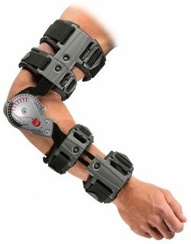

Figure 2. X-Act ROM Elbow joint stabilization solution

The X-Act ROM Elbow [2] is a device that is utilized to help protect patients post elbow surgery. This limits the patient's mobility or can completely immobilize the arm if it needs to heal in a certain position. This design is like many other elbow braces on the market for joint pain and recovery. What makes this design unique and stand out is the telescoping design and the double strap points to attach to the user’s arm.

Unlike X-Act ROM Elbow, RevEx is not meant to obstruct or limit movement of the elbow joint, but rather complement it and be as out of the way as possible. One of the most important design elements of RevEx’s mechanical design will be the method of mounting to the user’s arm. The telescoping, double strapped design of X-Act ROM Elbow caters to a variety of body types. This allows many different arm sizes to use the product. The double strapped and hybrid plastic/elastic band mounting system will most likely be adopted by RevEx, to allow rigid attachment to the arm.

Unfortunately, the current RevEx requirements will not allow for similar joint attachment. This is since the stepper motor must be mounted on the upper arm section so that the user’s elbow will not need to rotate the stepper mass as well. Therefore, RevEx must adopt a clamped design for the mating of the hinge between the upper and forearm sections of the package.

2.0 Project Packaging Description

The packaging for our project will consist of an arm brace mounted to the user’s arm. The basic design concept will be like the commercial products seen in Figure 1 and Figure 2 above. The main purpose of our product is to be lightweight and non-obstructive, so it will mostly be 3D printed and the circuit boards will be mounted directly on the upper-arm portion of the brace. The basic design concept can be seen in the dimensional drawing found in Appendix 1: Figure 3. The circular bands in the design will most likely be elastic to accommodate for varying arm sizes.

There will be a minimal amount of mounting hardware for the PCBs and brace attachment. This hardware can be seen in Appendix 2: Table 1. The amount of metal and other components was kept low to minimize the weight of the packaging. The estimated packaging weight does not include the weights of the PCBs and the stepper motor. The estimated total weight is around 700 grams accounting for the PCB components and stepper motor. This is a rough estimate as the total weight will need to be calculated from the prototype.

As for the PCB design, there will be two separate PCBs to help with weight distribution as well as noise reduction. Both PCBs can be found in Appendix 3, including dimensions and relative layouts. The Data Acquisition System (DAqS) PCB can be found in Appendix 3: Figure 4, while the Haptic-Feedback and Battery Management System (HBmS) PCB can be found in Appendix 3: Figure 5.

3.0 Sources Cited

[1] ALEx, *Kinetek Wearable Robotics*, Upper Limb Rehabilitation Device. Available from [Features - Wearable RoboticsWearable Robotics (wearable-robotics.com)](http://www.wearable-robotics.com/kinetek/products/alex/features/)

[2] X-Act ROM Elbow, *DonJoy*, Orthopedic brace. Available from [X-Act ROM Elbow DonJoy | e-MedicalBroker.com](https://e-medicalbroker.com/en/products/braces-supports/shoulder/upper-arm-shoulder-braces/x-act-rom-elbow-donjoy-2864.html)

Appendix 1: CAD Model Illustrations

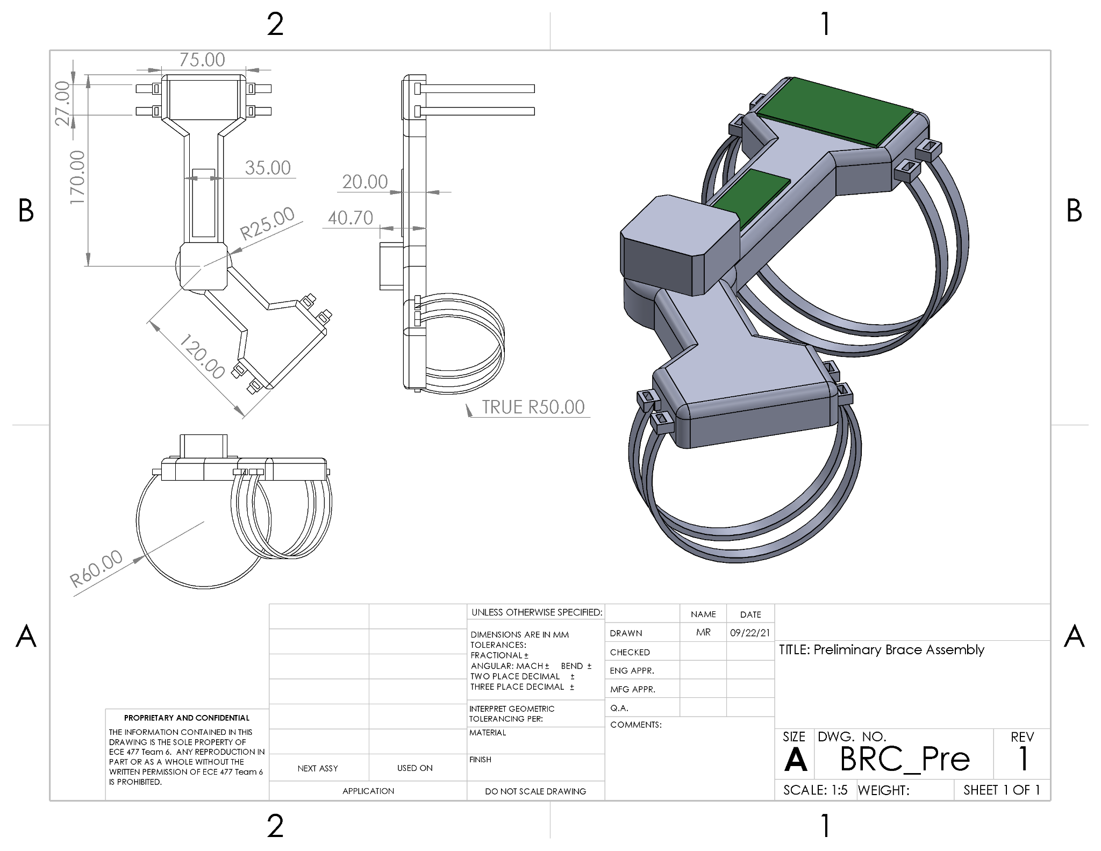

Figure 3. Preliminary Design Dimensional Drawing

Appendix 2: Project Packaging Specifications

Table 1: Material List

|  |  |  |  |
| --- | --- | --- | --- |
| **Material** | **Quantity** | **Weight** | **Cost** |
| PLA | ~350g | ~350g | $9.59 |
| M3 Screws | 8ct | 3.07g | $2.00 |
| M3 Nuts | 4ct | 1.54g | $1.25 |
| Elastic Bands | 1yrd | 11.62g | $0.99 |
| Ball Bearing | 1ct | 45.31g | $0.76 |
| Foam Padding | ~200 cm2 | 12.28g | $0.68 |
| TOTAL |  | 423.82g | $15.17 |

Table 2: Tooling Requirements:

|  |  |
| --- | --- |
| **Tooling** | **Estimated Cost** |
| 3D-Printing | Free with personally owned printer |
| Drill Press | N/A |

Estimated packaging weight: 423.82g

Estimated total weight: ~700g

Estimated packaging costs: $15.17

Appendix 3: PCB Footprint Layouts

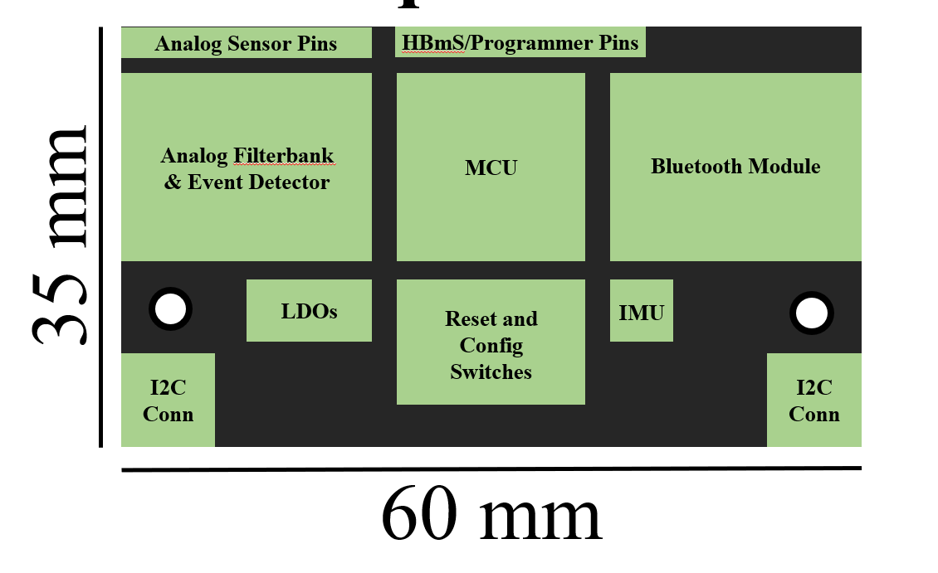

Figure 4. DAqS PCB Footprint Layout

Area Estimate: 2100 mm2 (21 cm2)

Number of Copies: 1

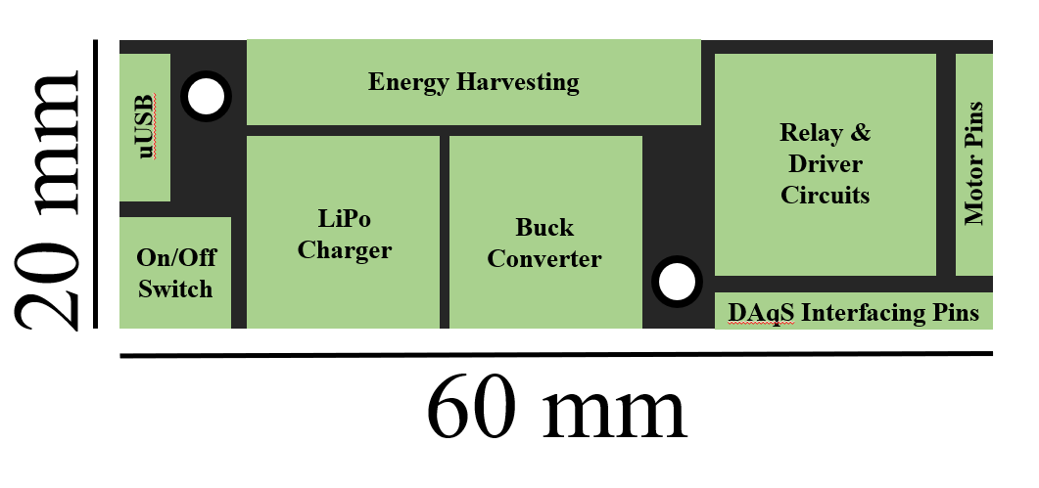

Figure 5. HBmS PCB Footprint Layout

Area Estimate: 1200 mm2 (12 cm2)

Number of Copies: 1